**Incoming students**

-As a student

-I want to know what the best college would be and major for me based on my financial status and major preferences

-So that I can set myself up for success and have a plan after I get my degree

Guidance counselor

-As a guidance counselor

-I want to be informed to help inform my students on what school and major would best fit their preferences

-So that they can be informed about their decision and be ready for after graduation

Financial advisor

-As a financial advisor

-I want to have the data to provide students and parents with the most financially fitting major and school for them

-So that they can afford their schooling while still getting a good learning experience

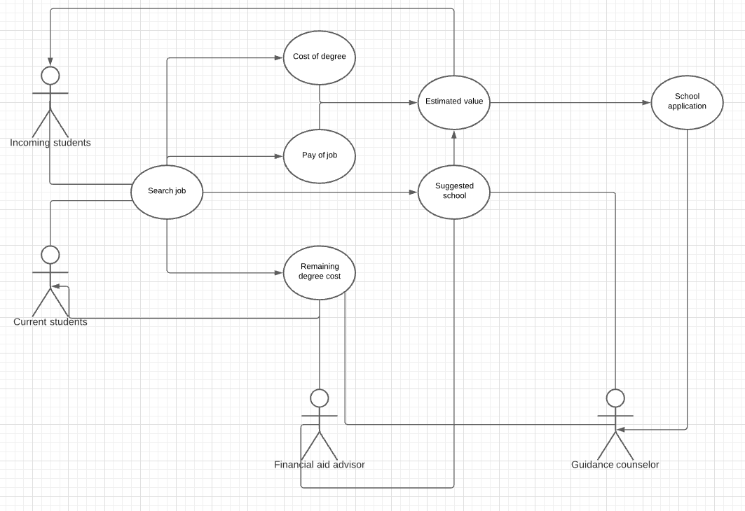

**Features**

-Give the average cost and job salary of the users searched major/degree

-Display the list of schools with the best programs for the users desired major and corresponding tuition costs

-Run the calculations to give the user the best school and major based on their set preferences and budget

-Give current students a calculation on how soon they can pay off their college loans based on their preferred plan